Attendees:
- Bob
- Shannon
- Tim
New Machine Thruput – Flattening Lines will need to be added as machines and additional filters added to assist in drilling down. The flattening line template will be made up of a combination of slitter and mill templates. Copy the slitter template and then it can be modified accordingly with the correct attributes.
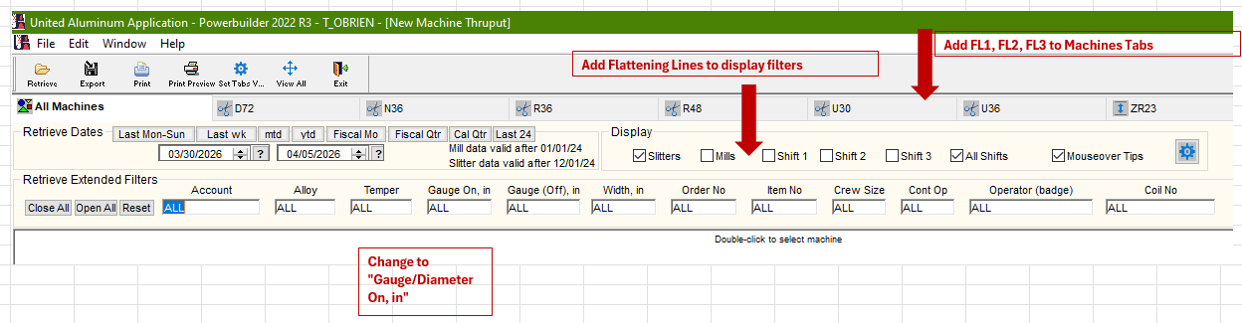

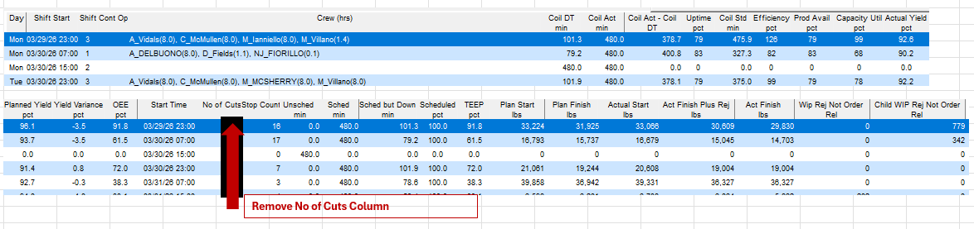

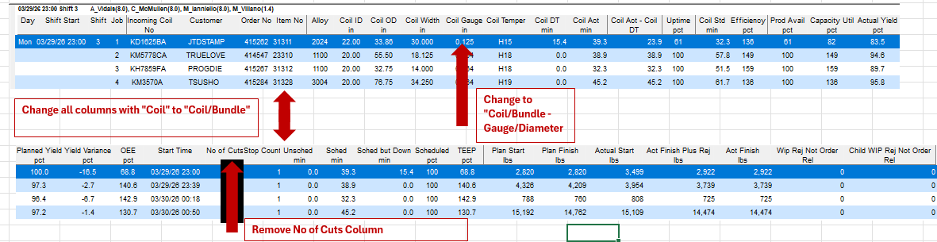

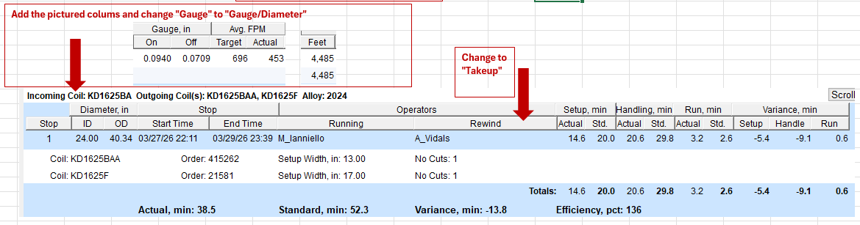
In screenshot below, modify the buckets/categories.
